**Comparing the Effectiveness of Using Games to Teach Binary to Students**

**Online and In-person**

**Abstract:** Underrepresented students have a declining success rate within technology. This study determines if video games are an effective medium for instructing students on complex programming concepts. The effectiveness of online versus in-person teaching is also being studied. The study is focused on students of all age ranges from middle school to college students. The [anonymous] at [anonymous] is a project-based class that provides a collaborative environment for students to explore new technology and learn to teach concepts in a simple, easy-to-learn manner. Binary concepts were taught through interactive 2D games built with Unity. Workshops were organized for students to learn binary by playing the game. Surveys before and after the workshops show that their understanding of binary improved significantly, and their interest in programming and game development also increased by 40% and 33% respectively. Game-based learning is effective in simplifying complex computing concepts, engaging students, and raising interest in technology.

**Keywords:** Unity, Binary, Undergraduate Students, Middle School Students, Video Games, Teaching, Workshops, Technology, Engagement, Maze, Board Game, Art

**Introduction**

Underrepresented students often do not have the best resources to help them feel included or prepared for their career in technology. They often times do not get exposed to technology at early ages. Engagement from students is a common challenge that professors face whenever students deem the concepts as difficult. Video games are an easy-to-understand method that helps students to stay engaged while learning difficult concepts. These games can be used for online classes as well as in-person classes. They are easy for professors to distribute to the class since they can be uploaded to an online hosting site. This removes the need for each student to install the game. These steps will increase inclusion, accessibility, and preparedness for students. [anonymous] aims to change this narrative for underrepresented students. [anonymous] is a project-based class that strives to increase participation in IT and STEM through numerous outreach activities and workshops to showcase the fun side of technology. The aim of this study is to determine if video games are a valid medium for instructing students on complex programming concepts. The effectiveness of online vs in-person teaching is also being studied. The study is focused on students of all age ranges from middle school to college students. Binary is the basis of how computers, photo editing, RGB, audio and many other technologies work, which is why we wanted to get students familiar with it early on. It is an entry point for students to gain an interest in programming if they have not been exposed to it because it relates to many different disciplines. It is also helpful for students who already have programming knowledge because they will gain a deeper understanding of how things like networking and computers work. Pixel Arcade is a project that will teahc students about these binary concepts as well as give them an opportunity to test their knowledge and understanding.

**The Study**

Pixel Arcade was built with Unity as the main technology. Unity is a popular cross-platform game engine used for developing 2D, 3D, AR, VR, and simulation-based projects. It uses C# as the programming language. This technology was used to build an interactive 2D game that will instruct participants about the basics of binary. Students will learn how binary is derived from base power of 2 since binary only uses 0’s and 1’s. They will then learn the positions and how to convert 4-bit binary to decimal and decimal back to 4-bit. To add more complexity, they will finally learn how to do the same conversions with 8-bits. The game has three mini games on display for students to play. The first game, Binary Maze, is a three-level game where students answer all of the questions on the level before moving on to the next level. The three levels consist of base power of 2, conversions through 4-bit, and conversions through 8-bit. The second game Planet 01000010 is a game where students move across a board by answering questions surrounding the concepts of binary. Students also answer questions on binary and decimal conversions in order to get the alien home as well. The final game RGB Paint, is a game where students are able to paint using binary to change the color of their pen. This is more of an explorative game since students can change the binary and observe the intensity of colors change. They get to try and make colors that are not already given to them. This RGB Paint game is disabled until students play either binary maze or planet 01000010 since those are the basis of the study.

Before the workshops, students were given a short survey to assess the user's prior knowledge of binary. After the survey, students were given a short introduction on the basics of binary and its conversions from binary to decimal and decimal to binary. Students were able to interact with the presentation by following along with the in-game tutorial that gave them 3 questions ranging from the power 2 to the binary conversion that goes to 6-bit. Once done, students were instructed to play their assigned game which was either Binary Maze or Planet 01000010, until the game was completed. Binary Maze was played by one online class and one in-person class. Planet 010000010 was played by the other online class and other in-person class. If the students finished their assigned game before the workshop was over, they were given an opportunity to play the game RGB Paint. Towards the end of the workshop, students were given a post survey to see what they were able to learn. We had two workshops that were online and two that were in-person. The online participants engaged by typing in the chat their finished scores. The in-person participants were able to get more help and wrote their scores on the board to have a live leaderboard.

The [anonymous] Expo was set up differently where team members were able to briefly explain their game while demonstrating all of its features. Once done, participants were then allowed to interact with the Unity game from the website. They were not able to get a full breakdown about binary and decimal conversion due to the lack of time given at the event. However, results were still collected after participants were done playing the mini games to get their feedback about the Unity game experience.

**Results**

Figure 1 displays the pre-survey results of college students when asked, "What is 9 in binary using 4 bits?" The results show that more than half of the students answered correctly, highlighting an improvement of the in-person students compared to the initial pre-survey data.

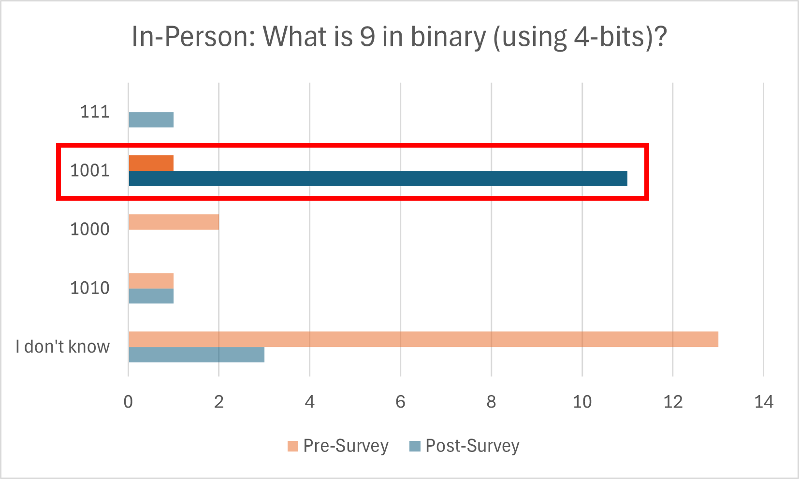

**Figure 1:** Pre-survey results of college students when asked what is 9 in binary using 4-bits?

Figure 2 shows the pre-survey results of online college students when asked, "What is 9 in binary using 4 bits?" The results indicate that online students had a higher initial score and more than doubled their scores in the post-survey, demonstrating significant improvement compared to the initial pre-survey data.

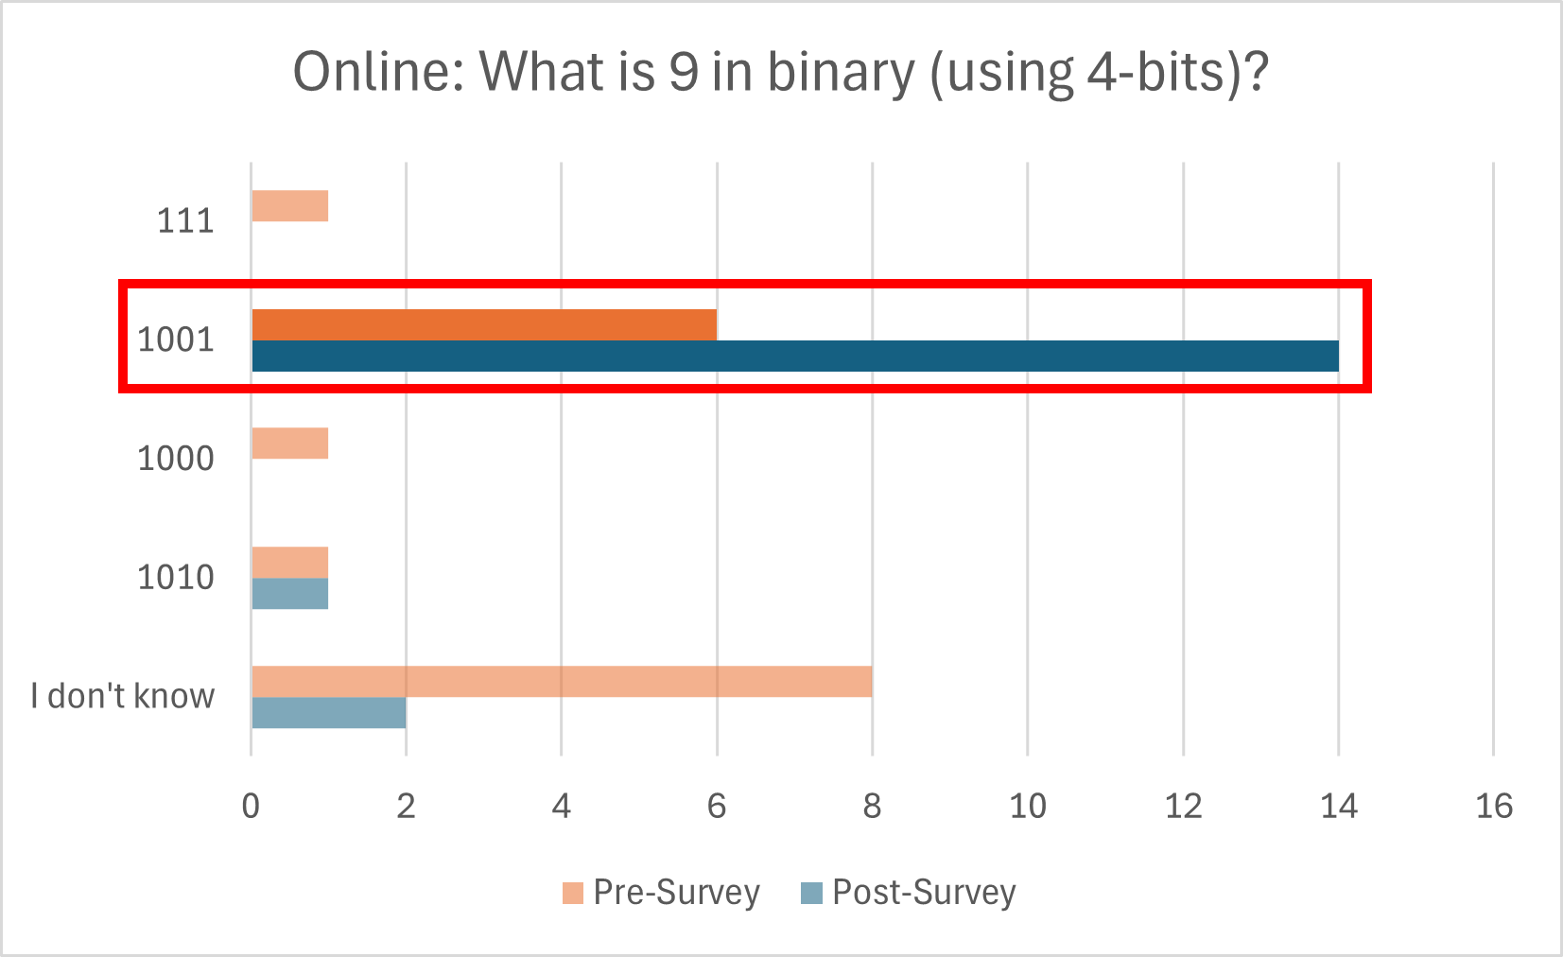

**Figure 2:** Post-survey results of college students when asked what is 9 in binary using 4-bits?

Figure 3 shows the survey results of in person college students when asked, "What is 10000011 in decimal?" The results indicate that none of the students did not know the correct answer, highlighting a gap in initial understanding for complex questions.

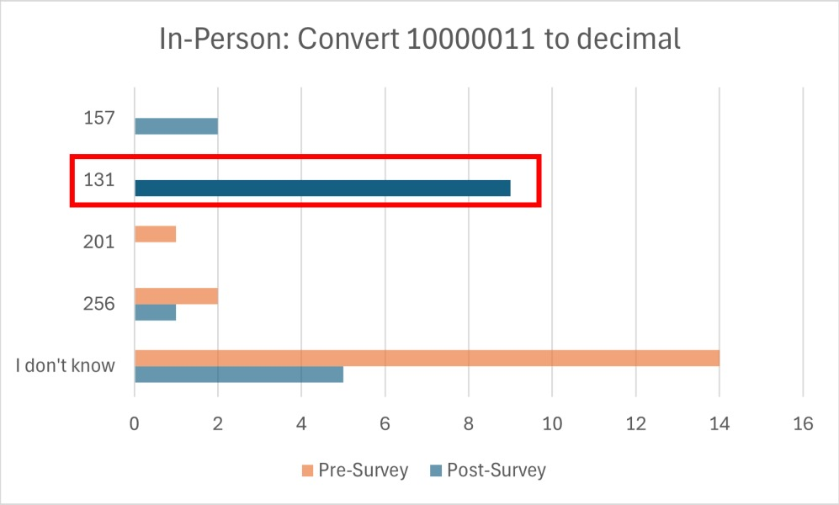

Figure 3: Pre-survey results of college students when asked to convert 10000011 to decimal.

Figure 4 shows the survey results of the online college students when asked, "What is 10000011 in decimal?" The results indicate an improvement, with correct responses increasing from 3 to 10.

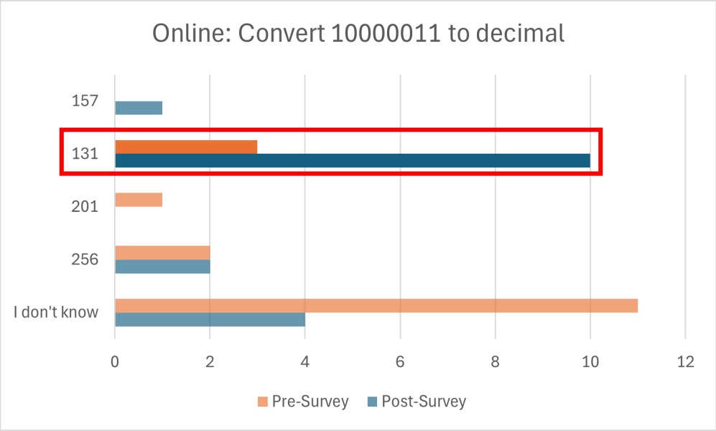

Figure 4: Post-survey results of college students when asked to convert 10000011 to decimal.

Figure 5 shows the post-survey data of college students on their interest in game development, with 40% responding "yes" to being curious about the field.

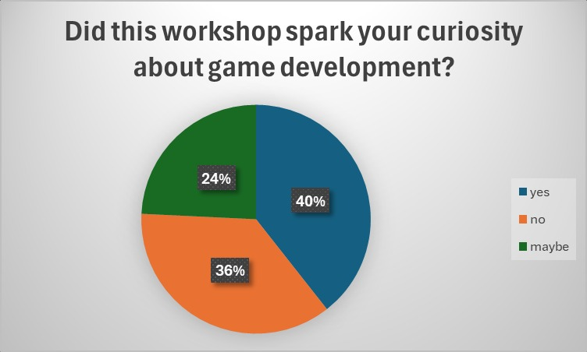

Figure 5: Post-survey data of college students about their curiosity in game development.

Figure 6 shows the post-survey data of college students on their interest in programming, with one-third indicating curiosity about the field.

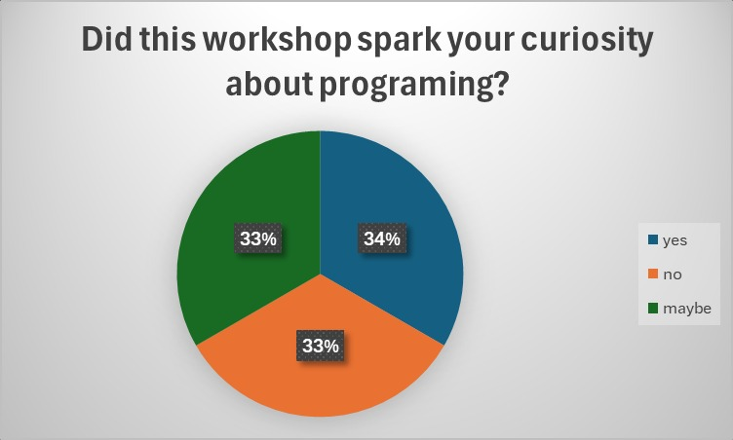

Figure 6: Post-survey data of college students about their curiosity in programming.

Figure 7 displays the effectiveness of in-person versus online learning on quiz performance, illustrating differences in growth rate and accuracy between the two groups.

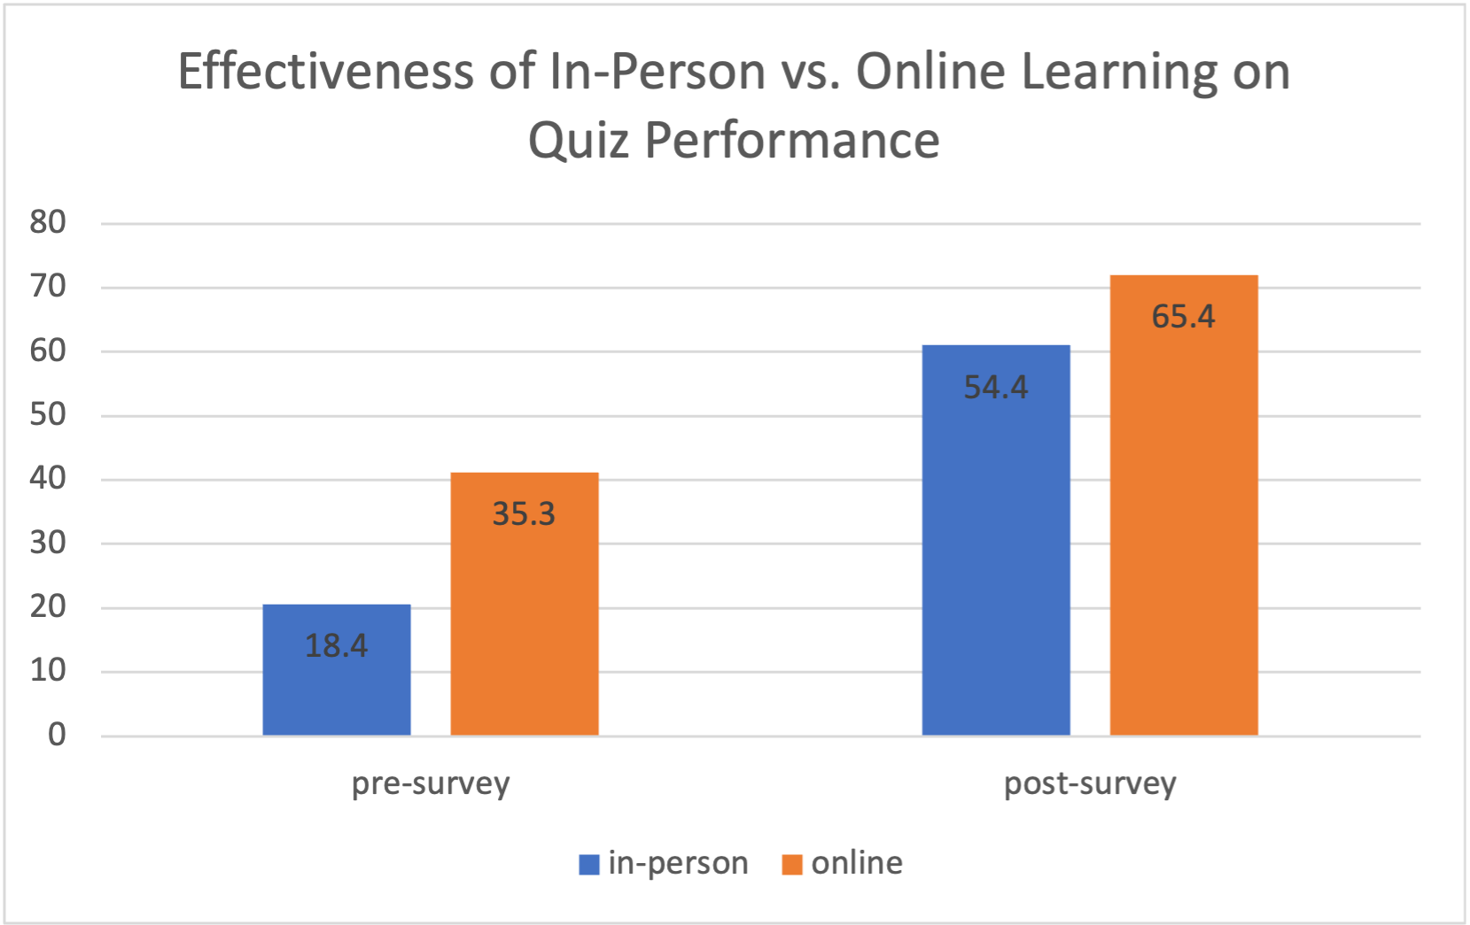

Figure 7: Effectiveness of In-Person vs. Online Learning on Quiz Performance

The results from our binary workshops were truly remarkable. Students demonstrated engagement and successfully grasped the concepts of converting decimal to and from binary. The majority of participants achieved impressive completion times and high accuracy rates, showcasing their understanding of the material. Both online and in-person students showed a gain of knowledge after the workshops by being able to identify the correct answer within the post-survey. Notably, this initiative sparked a 33% increase in interest in programming and a 40% boost in interest in game development among college students, indicating that the workshop effectively inspired them to explore these fields further. Additionally, the pre- and post-survey results were striking. Although the overall accuracy was higher in the online, the performance growth rate for in-person learning was notably higher (36%) compared to online (30.1%), illustrating the significant impact of our instruction. These results were based on a total of eight different questions designed to evaluate comprehension and retention effectively. These findings support the idea that video games are an effective medium for teaching complex topics like binary, as they engage students in ways that traditional methods may not.

The [anonymous] Expo provided an excellent platform to showcase how our project can be both educational and entertaining. Attendees had the chance to play three different games, each designed to present unique challenges while maintaining an element of fun. This hands-on experience not only reinforced the skills learned in the workshop but also highlighted the potential for engaging learning experiences in technology and coding. Overall, the success of the workshop and the positive feedback from the Expo participants underscore the impact of our initiative on student interest and engagement in programming and game development.

**References**

Adipat, S., Laksana, K., Busayanon, K., Asawasowan, A., & Adipat, B. (2021). Engaging students in the learning process with game-based learning: The fundamental concepts. *International Journal of Technology in Education (IJTE)*, 4(3), 542-552. <https://doi.org/10.46328/ijte.169>

[anonymous]

“Unity Real-Time Development Platform: 3D, 2D, VR & AR Engine.” Unity, <https://unity.com/>. Accessed 23 Sept. 2024.

Wisc-Online. "Hexadecimal Bee Game." *Wisc-Online Arcade*, [www.wisc-online.com/arcade/games/computer-science/foundational-it-skills/2169/hexadecimal-bee-game](http://www.wisc-online.com/arcade/games/computer-science/foundational-it-skills/2169/hexadecimal-bee-game).

**Acknowledgements**

This project has been partially funded by the National Science Foundation grant #2315804. We would also like to thank the [anonymous] faculty and students, and the [anonymous] School of Science & Technology for supporting the [anonymous] program.